A PROJECT REPORT ON

**“**Office Management System**”**

SUBMITTED IN PARTIAL FULFILLMENT OF THE REQUIREMENTS FOR THE AWARD OF **DIPLOMA IN**

Computer Engineering

**SUBMITTED TO**

MAHARASHTRA STATE BOARD OF TECHNICAL EDUCATION, MUMBAI

**SUBMITTED BY**

Name of Student(s) (Full Name) Enrollment No.

|  |  |
| --- | --- |
| **1. Neha Dipak Sattarwale** | **1916110056** |
| **2. Naushin Chandsab Diggi** | **1916110049** |
| 1. **Almas Hazratali Walikar** 2. **Alfiya Mazhar Shaikh** 3. **Kashaf Riyaz Ahmed**   **Fulari** | **1916110042**  **1916110033**  **1916110057** |

**GUIDED BY**

Prof.Basate B.A

**Maulana Azad Polytechnic Solapur**

**2021-2022**



**Maulana Azad Polytechnic Solapur**

## CERTIFICATE

**This is to Certify that the project report entitled “Office Management System” Was successfully completed by Student of sixth semester Diploma in (Computer).**

|  |  |
| --- | --- |
| **Neha Dipak Sattarwale** | **1916110056** |
| **Naushin Chandsab Digg** | **1916110049** |
| **Almas Hazratali Walikar** | **1916110042** |
| **Alfiya Mazhar Shaikh** | **1916110033** |
| **Kashaf Riyaz Ahmed Fulari** | **1916110057** |

**in partial fulfilment of the requirements for the award of the Diploma in Computer and submitted to the Department of Computer of Maulana Azad Polytechnic Solapur work carried out during a period for the academic year 2021-22 as per curriculum.**

**Prof.Basate B.A Mr.Shaikh M.A**

**Guide HOD**

**External Examiner Principal**



**MAHARASHTRA STATE BOARD OF TECHNICAL EDUCATION, MUMBAI.**

**CERTIFICATE**

This is to certify that, student of third year computer engineering department of MaulanaAzad Polytechnic, Solapur (Code: 1611) are successfully implemented the project reporton **“Office Management System”** in partial fulfillment of Diploma course in computer engineering during academic of 2021-2022

Submitted by

|  |  |
| --- | --- |
| **Name** | **Enrollment no** |

**Neha Dipak Sattarwale 1916110056**



**DEPARATMENT OF COMPUTER ENGINEERING MAULANA AZAD POLYTECHNIC, SOLAPUR**

**Project Guide H.O.D.**

(Prof. Basate B.A.) (**Mr.Shaikh M.A)**

**Principal Examiner**



**MAHARASHTRA STATE BOARD OF TECHNICAL EDUCATION, MUMBAI.**

**CERTIFICATE**

This is to certify that, student of third year computer engineering department of Maulana Azad Polytechnic, Solapur (Code: 1611) are successfully implemented the project report on **“Library Automation System”** in partial fulfillment of Diploma course in computer engineering during academic of 2021-2022

Submitted by

|  |  |
| --- | --- |
| **Name** | **Enrollment no** |

**Naushin Chandsab Digg 1916110049**



**DEPARATMENT OF COMPUTER ENGINEERING MAULANA AZAD POLYTECHNIC, SOLAPUR**

**Project Guide H.O.D.**

(Prof. Basate B.A.) (**Mr.Shaikh M.A**.)

**Principal Examiner**



**MAHARASHTRA STATE BOARD OF TECHNICAL EDUCATION, MUMBAI.**

**CERTIFICATE**

This is to certify that, student of third year computer engineering department of Maulana Azad Polytechnic, Solapur (Code: 1611) are successfully implemented the project report on **“Office Management System”** in partial fulfillment of Diploma course in computer engineering during academic of 2021-2022

Submitted by

|  |  |
| --- | --- |
| **Name** | **Enrollment no** |

**Almas Hazratali Walikar 1916110042**





**DEPARATMENT OF COMPUTER ENGINEERING MAULANA AZAD POLYTECHNIC, SOLAPUR**

**Project Guide H.O.D.**

(Prof. Basate B.A.) (**Mr.Shaikh M.A**.)

**Principal Examiner**



**MAHARASHTRA STATE BOARD OF TECHNICAL EDUCATION, MUMBAI.**

**CERTIFICATE**

This is to certify that, student of third year computer engineering department of Maulana Azad Polytechnic, Solapur (Code: 1611) are successfully implemented the project report on **“Office Management System”** in partial fulfillment of Diploma course in computer engineering during academic of 2021-2022

Submitted by

|  |  |
| --- | --- |
| **Name** | **Enrollment no** |

**Alfiya Mazhar Shaikh 1916110033**



**DEPARATMENT OF COMPUTER ENGINEERING MAULANA AZAD POLYTECHNIC, SOLAPUR**

**Project Guide H.O.D.**

(Prof. Basate B.A.) (**Mr.Shaikh M.A)**

**Principal Examiner**



**MAHARASHTRA STATE BOARD OF TECHNICAL EDUCATION, MUMBAI.**

**CERTIFICATE**

This is to certify that, student of third year computer engineering department of Maulana Azad Polytechnic, Solapur (Code: 1611) are successfully implemented the project report on **“Office Management System”** in partial fulfillment of Diploma course in computer engineering during academic of 2021-2022

Submitted by

|  |  |
| --- | --- |
| **Name** | **Enrollment no** |

**Kashaf Riyaz Ahmed Fulari 1916110057**



**DEPARATMENT OF COMPUTER ENGINEERING MAULANA AZAD POLYTECHNIC, SOLAPUR**

**Project Guide H.O.D.**

(Prof. Basate B.A.) (**Mr.Shaikh M.A**.)

**Principal Examiner**

**Acknowledgement**

The success and final outcome of this project required a lot of guidance and assistance from many people and I am extremely privileged to have got this all along the completion of my project. All that I have done is only due to such supervision and assistance and I would not forget to thank them.

I respect and thank to our principal **Prof. Basate B.A.** for providing me an opportunity to do the project work in **“Office Management System”** and I also thank to our **HOD Mr.Shaikh M.A**

for giving us all support and guidance which made me complete the project duly.

I owe my deep gratitude to our project guide **Prof. Basate B.A.** who look keen interest on our project work and guided us all along, till the completion of our project work by providing all the necessary information for developing a good system.

I am thankful to and fortunate enough to get constant encouragement, support and guidance from all Teaching staffs of computer department which helped us in successfully completing our project work. Also, I would like to extend our sincere esteems to all staff in computer lab for their timely support.

|  |  |  |
| --- | --- | --- |
|  | **CONTENTS** | **PAGE**  **NO** |
| **1** | **INTRODUCTION** | **iv** |
|  | 1.1 Project Overview(Abstract) | **vii** |
|  | 1.2 Proposed System | **ix** |
|  | 1.3 Scope of the project |  |
|  | 1.4 Introduction to Language |  |
| **2** | **FEASIBLITY STUDY** | **1** |
|  | 2.1 Project Feasibility | 1 |
|  | 2.2 Hardware Specification | 1 |
|  | 2.3 Software Specification |  |
| **3** | **SYSTEM DESIGN** | **2** |
|  | 3.1 Database Design | 2 |
|  | 3.2 Entity Relationship Diagram(ERD) | 2 |
|  | 3.3 Data Flow Diagram(DFD) |  |
|  | 3.4 Output Screens |  |
| **4** | **ADVANTAGES** | **3** |
| **5** | **FUTURE SCOPE** | **3** |
| **6** | **FUTURE ENHANCEMENT** | **3** |
| **7** | **CONCLUSION** | **4** |
| **8** | **BIBLOGRAPHY** | **4** |
| **9** | **CODE SCRIPT** | **4** |

# INTRODUCTION

###### PROJECT OVERVIEW(ABSTRACT):

The office automation system is an application that is designed to automate the processes that take place in the college office. There are many matters regarding the college that need to be maintained through the online method with the help of some application. The activities, student details and many matters like this can be better managed by the applications which are capable in doing this task. The admission details, students and faculty's information, feedback system performance of the students, reviews of the particular colleges, suggestions that can be given in some matters needed for improvement can all be dealt easily using the office automation system application.

**The existing system involves a lot of human effort and it is difficult to maintain all the records manually through pen paper method. The office** automation application must be having a strong back end system to store all **the database of the college. This application will help in smooth running of the college management.**

###### Proposed System

Our proposed system is an “Area Wise Masjid Tracking App” that enables ease for the peoples. It overcomes the disadvantages of the old system. This system improve the user interface as well as the user experience. This application find the masjid according to the area. To find any masjid user need to first search the area . Then user can select the nearest masjid to his/her area. After selecting masjid it shown all the information about that selected masjid like prayer time masjid name trusty name and contact etc.. The proposed system provides faster execution. The proposed system does not have any possibilities of data losing during processing. This proposed systemdesigned to search nearest masjid in particular area.

###### Scope of the Project:

Many articles in this first issue deal primarily with people issues and a knowledge of the technology is assumed. Meyer's article takes the reader on a quick tour of office information tools. As a foundation for discussion, it defines the scope, history, and current status of office automation. The office technology of today rests on a basis laid over decades by a number of management disciplines. Although there is a plenty of proof that office automation can quantitatively increase office output, it is the combination of qualitative and quantitative improvements that distinguishes today's office automation. The means to achieving this balance is a good office automation manager, able to coordinate various technologies and equally able to manage the people issue.

* 1. **Introduction To Language**

What is VB.NET?

* + - VB.NET is a multi-paradigm programming language developed by Microsoft on the .NET framework. It was launched in 2002 as a successor to the Visual Basic language. This was the first version of VB.NET (VB.NET 7.0) and it relied on .NET version 1.0.
    - In 2003, the second version of VB.NET, VB.NET 7.1, was released. This one relied on

.NET version 1.1. This version came with a number of improvements including support for

.NET Compact Framework and an improved reliability and performance of the .NET IDE. VB.NET 2003 was also made available in the academic edition of Visual Studio.NET and distributed to various scholars from different countries for free.

* + - In 2005, VB.NET 8.0 was released. The .NET core portion was dropped from its name so as to distinguish it from the classical Visual Basic language. This version was named Visual Basic 2005. This version came with many features since Microsoft wanted this language to be used for rapid application developers. They also wanted to make it different from C# language. Some of the features introduced by this version of VB.NET included partial classes, generics, nullable types, operator overloading, and unsigned integer support. This version also saw the introduction of the IsNot operator.
    - In 2008, VB 9.0 was introduced. This was released together with .NET 3.5. Some of the features added to this release of VB.NET included anonymous types, true conditional operator, LINQ support, XML literals, Lambda expressions, extension methods, and type inference.
    - In 2010, Microsoft released VB 2010 (code 10.0). They wanted to use a Dynamic Language Runtime for this release, but they opted for co-evolution strategy shared between VB.NET and C# to bring these languages closer to each other.
    - In 2012, VB 2012 (code 11.0) was release together with .NET 4.5. Its features included call hierarchy, caller data, asynchronous programming with "await" and "async" statements and the "Global" keyword in the "namespace" statements.
    - In 2015, VB 2015 (code 14.0) was released alongside Visual Studio 2015. The "?." operator was introduced to do inline null checks. A string interpolation feature was also introduced to help in formatting strings inline.
    - In 2017, VB 2017 (code 15.0) was introduced alongside Visual Studio 2017. A better way of organizing source code in just a single action was introduced.

##### Application

VB.NET comes loaded with numerous features that have made it a popular programming language amongst programmers worldwide. These features include the following:

* + - VB.NET is not case sensitive like other languages such as C++ and Java.
    - It is an object-oriented programming language. It treats everything as an object.
    - Automatic code formatting, XML designer, improved object browser etc.
    - Garbage collection is automated.
    - Support for Boolean conditions for decision making.
    - Simple multithreading, allowing your apps to deal with multiple tasks simultaneously.
    - Simple generics.
    - A standard library.

1. **FEASIBLITY AND STUDY**
   1. FEASIBILITY STUDY

As the name implies, a feasibility analysis is used to determine the viability of an idea, such as ensuring a project is legally and technically feasible as well as economically justifiable. It tells us whether a project is worth the investment—in some cases, a [project](https://www.simplilearn.com/what-is-a-project-article) may not be doable. There can be many reasons for this, including requiring too many resources, which not only prevents those resources from performing other tasks but also may cost more than an organization would earn back by taking on a project that isn’t profitable.

A well-designed study should offer a historical background of the business or project, such as a description of the product or service, accounting statements, details of operations and management, marketing research and policies, financial data, legal requirements, and tax obligations. Generally, such studies precede technical development and [project implementation.](https://www.simplilearn.com/project-implementation-guide-to-save-money-rar303-article)

Types of Feasibility Study

A feasibility analysis evaluates the project’s potential for success; therefore, perceived objectivity is an essential factor in the credibility of the study for potential investors and lending institutions. There are five types of feasibility study—separate areas that a feasibility study examines, described below.

1. Technical Feasibility

This assessment focuses on the technical resources available to the organization. It helps organizations determine whether the technical resources meet capacity and whether the technical team is capable of converting the ideas into working systems. Technical feasibility also involves the evaluation of the hardware, software, and other technical requirements of the

proposed system. As an exaggerated example, an organization wouldn’t want to try to put Star Trek’s transporters in their building—currently, this project is not technically feasible.

1. Economic Feasibility

This assessment typically involves a cost/ benefits analysis of the project, helping organizations determine the viability, cost, and benefits associated with a project before financial resources are allocated. It also serves as an independent [project assessment](https://www.simplilearn.com/risk-assessment-project-management-article) and enhances project credibility— helping decision-makers determine the positive economic benefits to the organization that the proposed project will provide.

1. Legal Feasibility

This assessment investigates whether any aspect of the proposed project conflicts with legal

requirements like zoning laws, data protection acts or social media laws. Let’s say an organization wants to construct a new office building in a specific location. A feasibility study might reveal the organization’s ideal location isn’t zoned for that type of business. That organization has just saved considerable time and effort by learning that their project was not feasible right from the beginning.

1. Operational Feasibility

This assessment involves undertaking a study to analyze and determine whether—and how well— the organization’s needs can be met by completing the project. Operational feasibility studies also examine how a project plan satisfies the requirements identified in the requirements analysis phase of system development.

* 1. **HARDWARE REQUIREMENTS**
  + Processor : Pentium 4 or above.
  + Hard disk : 50GB
  + RAM : 512 MB or more

###### SOFTWARE REQUIREMENTS

* + - Operating System : Windows 7/Windows 10
    - User Interface : Microsoft Visual Studio
    - Database : Microsoft SQL

# SYSTEM DESIGN

### ER DIAGRAM:

**Admin**

**Course**

**Dept_name**

**Donation Fees**

**Course**

**Staff_name**

**Address**

**User Name**

**Do**



**Fees**

**Password**

**Login**

**Tutuion fees Exam fees**

**ADD**

**Goto**

Dashbord

**Do**

**Logout**

**Mb_no**

**Staff**

**ADD**

**Work**

**Select_staff**

|  |  |
| --- | --- |
| **Date** | **Staff Attandance** |
| **Mobile_No** |  |

**Mb_No**

**Staff_ID**

**Student Name**

#### Student

**Address**

**ADD**

**ADD**

**ADD**

**Select Course Subject name**

**Exam**

**Selact course**

**Total marks**

**Passing marks**

**Depertment**

**Dept name**

**Date of exam**

**Total fess**

**Receipt**

**Payed fess**

### Fees

**ADD**

**Pending fess**

**Select Student**

**Vie**

###### ENTITY RELATIONSHIP DIAGRAM(ERD)

Entity Relationship Diagram, also known as ERD, ER Diagram or ER model, is a type of structural diagram for use in database design. An ERD contains different symbols and connectors that visualize two important information: **The major entities within the system scope**, and the **inter-relationships among these entities**.

And that's why it's called "Entity" "Relationship" diagram (ERD)!

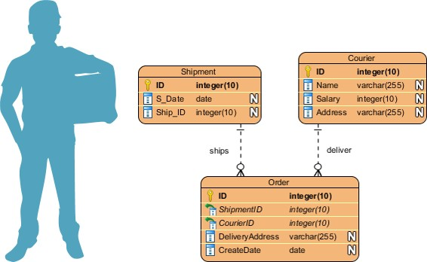When we talk about entities in ERD, very often we are referring to business objects such as people/roles (e.g. Student), tangible business objects (e.g. Product), intangible business objects (e.g. Log), etc. "Relationship" is about how these entities relate to each other within the system.

In a typical ER design, you can find symbols such as rounded rectangles and connectors (with different styles of their ends) that depict the entities, their attributes, and inter-relationships.

###### DATA FLOW DIAGRAM(DFD):

**Staff Selection**

###### Add Staff Attendance

**Office MANAGEMEN T SYSTEM**

**0.0**



**Fees Section**

**Add Student Section**

**Add Exam**

Admin

**Course Selection**

Flow chart: Admin:

**login**

**Dashboard**

**Course**

**Staff Selection**

**Exam Selection**

**Student Selection**

**Logout**

**Level 1 DFD:**

**Add Course**

**Tbl_Course**

**Course Selection**

**Add Staff**

**Tbl_Staff**

**Staff Selection**

**Staff Attendance**

**Tbl_Attendance**

**Staff Attendance**

**Add Exam**

**Tbl_Exam**

**Exam Selection**

**Add Student**

Tbl_ Student

**Student Selection**

**Fess**

**Tbl_Fees**

**Fees Selection**

1. **ADVANTAGES**
   * Easy to use and understand.
   * Easy to find location of any masjid in that particular area
   * Time management.
   * Everyone can use this app.

# SCOPE

The purpose of the Project Office Automation System (OAS) is to construct an application that can simplify operations in the college office. Using this, it is possible to maintain a database of college records, such as information about students enrolled in different classes, employee information in different departments, staff and non-staff descriptions, etc. The transaction containing payments and wages is also held Receipts of fees are provided for students Reports are preserved for future use. The search engine is used to search for the necessary details

Use of Office automation system

The purpose of this project is to simplify the work of the office. The existing procedure in the workplace is a manual system that requires a paper sheet. It is very difficult to keep track of all the information in such a system The purpose of our project is to develop an application that will automate processes in a college office.

# FUTURE ENHANCEMENT

In any project, though present satisfaction is important but also it is equally important to see and visualize the future scope. The project which is developed now may be need to undergo some changes in future in order to match up the technology prevailing that time, thus change due to development in technology are advisable.

This software project is a library management software system with all the basic as well as some innovative features for managing a library(ebook mailing and expiry notification via sms). It consists of a large database of various books available in the library. It also lists various books issued to respective readers.

The system keeps track of all the books readily available and also the books that have been issued to various readers the time period for which the books have been issued.

If the reader needs an ebook, the ebook can be directly mailed to the client email id through the system through a single click. Readers usually tend to forget the date to resubmit their library books so these books that have been issued to the reader and have reached their expiry date, an sms notification is sent to the reader automatically by the system to remind him about the book return date. Thus this innovative library management system provides an enhanced library functionality for this modern day.

# CONCLUSION

It is not possible to develop a system that makes all the requirements of the user. User requirements keep changing as the system is being used. Web development is a very flexible and much functionality can be added it, to enhancement performance of the project title ELECTRONIC SHOP MANAGEMENT SYSTEM those options that are not included in the software can be included to improve the efficiency of the software. The system is developed such a way that if any modifications and enhancements are needed in future, can be done at ease without disturbing the proper working of the system

Thus this project is sure to make an impact in the current scenario where this website is actually a necessary in an educational institution.

# BIBLIOGRAPHY

* + - <https://en.wikipedia.org/wiki/Steganography>
    - <https://github.com/aagarwal1012/Image-Steganography-Library-Android>
    - <https://github.com/lukefire5156/Steganography-App>
    - <https://www.geeksforgeeks.org/image-steganography-in-cryptography/>

# CODE SCRIPT

###### DASHBOARD

**using System;**

**using System.Collections.Generic; using System.ComponentModel; using System.Data;**

**using System.Drawing; using System.Linq; using System.Text;**

**using System.Windows.Forms;**

**namespace OfficeManagementSystem**

**{**

**public partial class Dashboard : Form**

**{**

**public Dashboard()**

**{**

**InitializeComponent();**

**}**

**private void Dashboard_Load(object sender, EventArgs e)**

**{**

**WindowState = FormWindowState.Maximized;**

**}**

**private void btnDashboard_Click(object sender, EventArgs e)**

**{**

**panelMini.Height = btnDashboard.Height; panelMini.Top = btnDashboard.Top; homePage1.BringToFront();**

**}**

**private void btnCourse_Click(object sender, EventArgs e)**

**{**

**panelMini.Height = btnCourse.Height; panelMini.Top = btnCourse.Top; addCourse1.BringToFront();**

**}**

**private void btnStaffSection_Click(object sender, EventArgs e)**

**{**

**panelMini.Height = btnStaffSection.Height; panelMini.Top = btnStaffSection.Top; staffHome1.BringToFront();**

**}**

**private void btnExam_Click(object sender, EventArgs e)**

**{**

**panelMini.Height = btnExam.Height; panelMini.Top = btnExam.Top; addExam1.BringToFront();**

**}**

**private void btnStudentSection_Click(object sender, EventArgs e)**

**{**

**}**

**private void btnAboutUs_Click(object sender, EventArgs e)**

**{**

**}**

**private void btnLogout_Click(object sender, EventArgs e)**

**{**

**}**

**private void btnStudentSection_Click_1(object sender, EventArgs e)**

**{**

**panelMini.Height = btnStudentSection.Height; panelMini.Top = btnStudentSection.Top; studentHome1.BringToFront();**

**}**

**private void btnAboutUs_Click_1(object sender, EventArgs e)**

**{**

**panelMini.Height = btnAboutUs.Height; panelMini.Top = btnAboutUs.Top; aboutUs1.BringToFront();**

**}**

**private void btnLogout_Click_1(object sender, EventArgs e)**

**{ panelMini.Height = btnLogout.Height;**

**panelMini.Top = btnLogout.Top;**

**//dashboard1.BringToFront();**

**}**

**}**

**}**

**Login Page:**

**using System;**

**using System.Collections.Generic; using System.ComponentModel; using System.Data;**

**using System.Drawing; using System.Linq; using System.Text;**

**using System.Windows.Forms; namespace OfficeManagementSystem**

**{**

**public partial class LoginForm : Form**

**{**

**public LoginForm()**

**{**

**InitializeComponent();**

**}**

**private void LoginForm_Load(object sender, EventArgs e)**

**{**

**}**

**private void btnExit_Click(object sender, EventArgs e)**

**{**

**this.Close();**

**}**

**private void btnLogin_Click(object sender, EventArgs e)**

**{**

**if (txtUname.Text == "Admin" && txtPassword.Text == "Pass123")**

**{**

**MessageBox.Show("Welcome to Office Management System"); this.Hide();**

**Dashboard ob = new Dashboard(); ob.Show();**

**}**

**else**

**MessageBox.Show("Please Check user name and Password!!**

**txtUname.Text = ""; txtPassword.Text = "";**

**}**

**}**

**}**

**}**

**SEARCH MASJID**

<?xml version="1.0" encoding="utf-8"?>

<LinearLayout xmlns:android[="http://schemas.android.com/apk/res/android"](http://schemas.android.com/apk/res/android) xmlns:tools[="http://schemas.android.com/tools"](http://schemas.android.com/tools) android:layout_width="match_parent" android:layout_height="match_parent"

android:background="#fff" android:orientation="vertical" tools:context=".SearchMasjid">

<ImageView

android:layout_width="100dp" android:layout_height="100dp" android:layout_marginLeft="25dp"

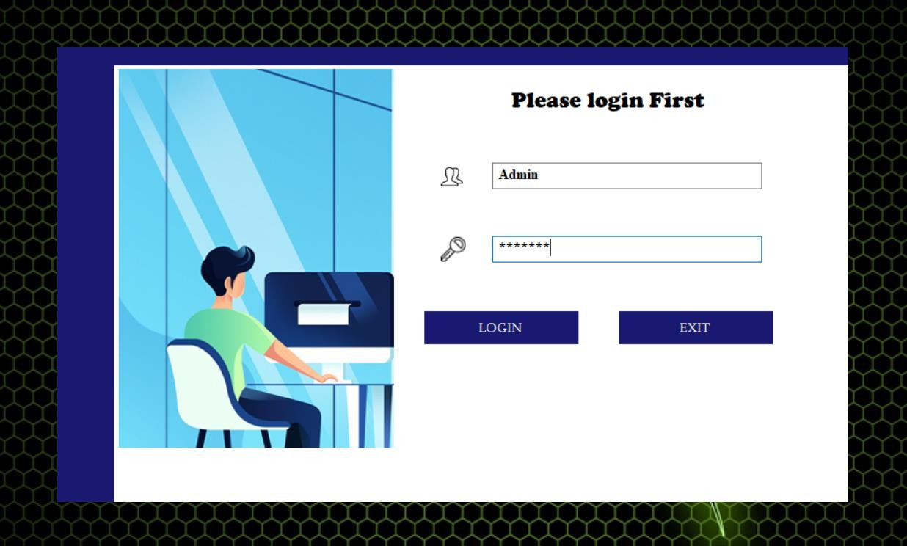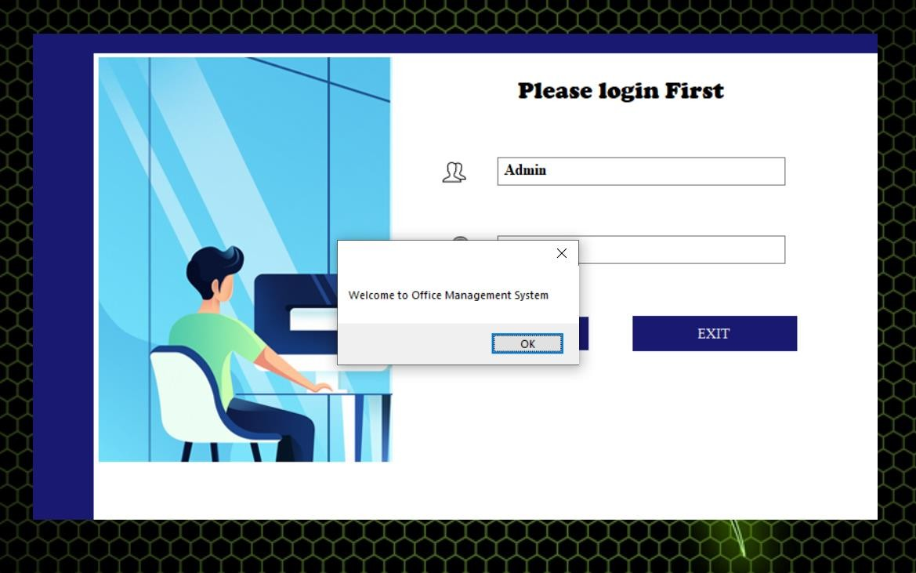

### Dash Board:-

**Course :-**

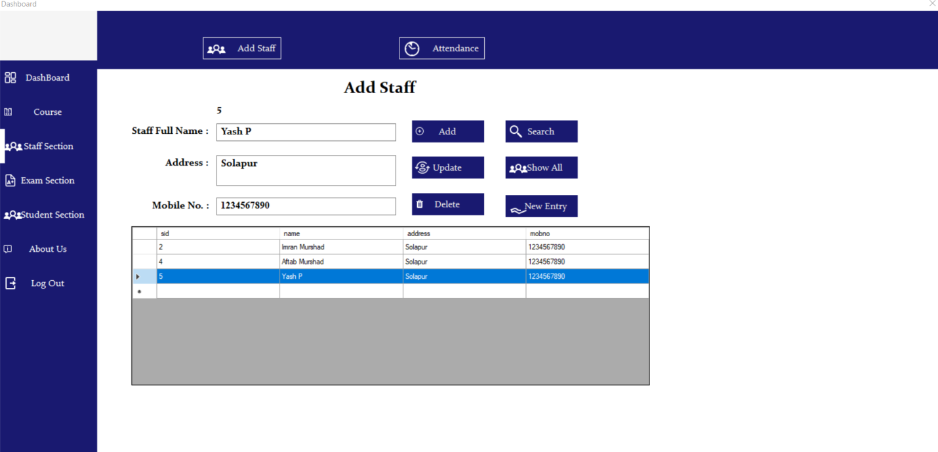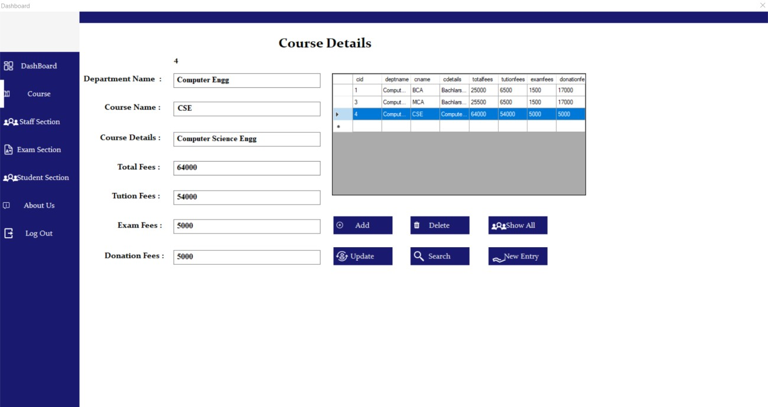

**Staff Selection:-**

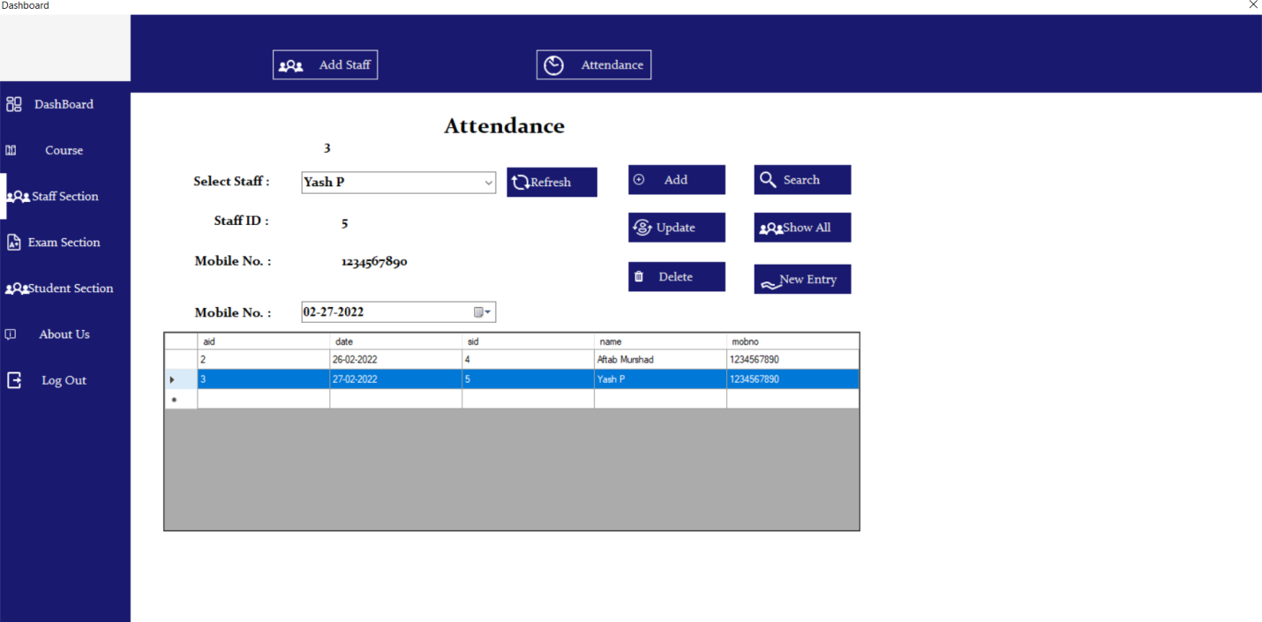

### Exam Slection:-

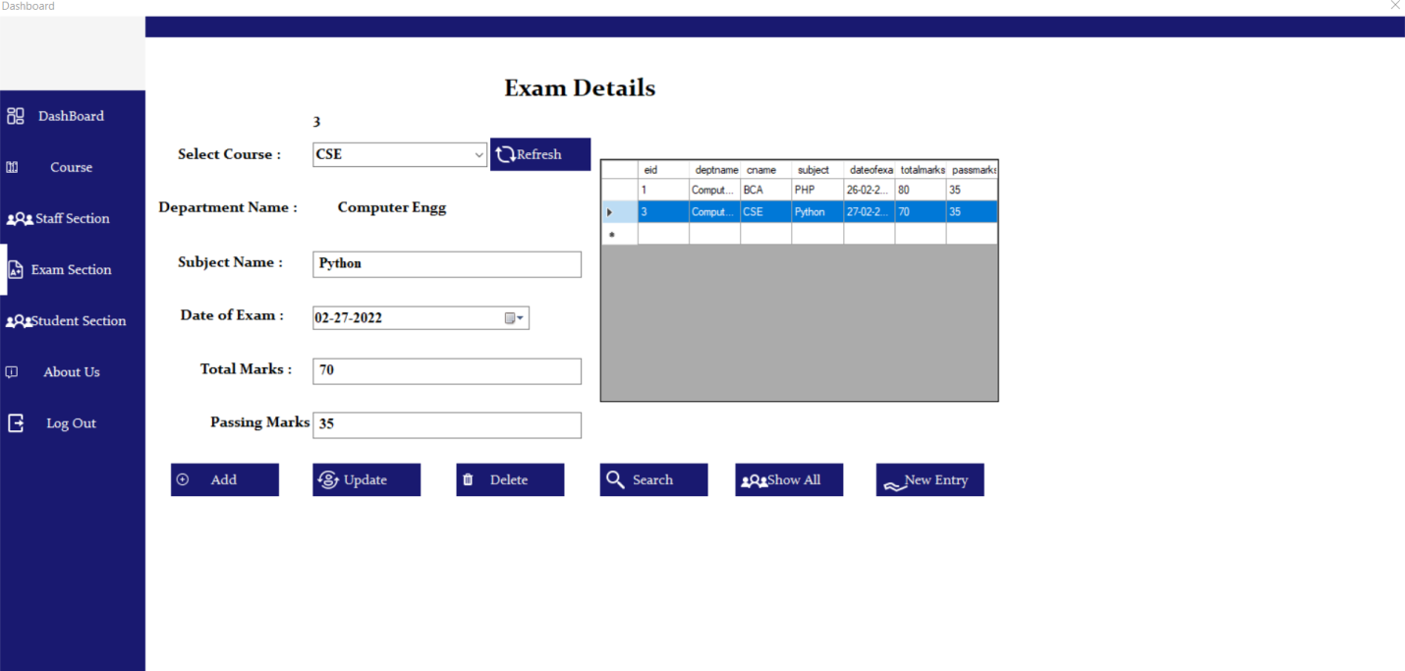

**Student Selection:-**

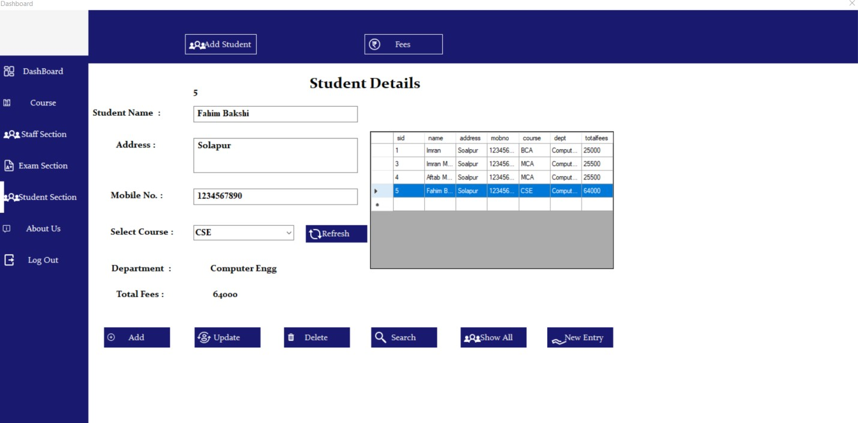

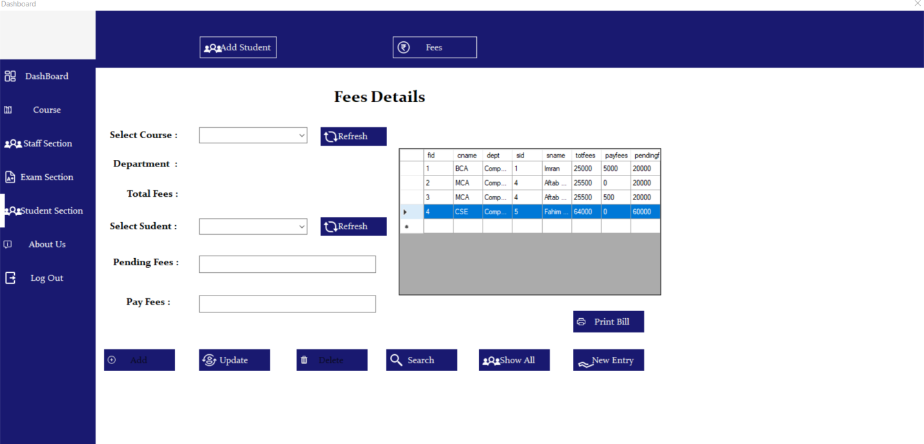**Fess Details :-**